David Hudson

Lab 6

MVCMusicStore Video Commit ID 37a257f5

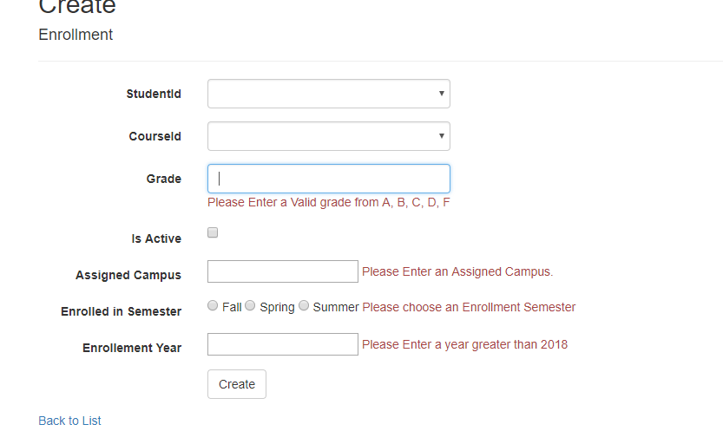

Lab 6 Commit 57f37623